**Bahria University,**

Karachi Campus



## LAB EXPERIMENT NO.

## 6

## LIST OF TASKS

|  |  |
| --- | --- |
| **TASK NO** | **OBJECTIVE** |
| **1** | Modus Ponens Task: Scenario: You're developing a security system for a bank vault. Implement a function that checks if the security camera detects unauthorized access. If the camera detects unauthorized access, trigger the alarm system. Objective: Use modus ponens to activate the alarm system when unauthorized access is detected, demonstrating how logical inference triggers actions in a security system. |
| **2** | Modus Tollens Task: Scenario: You're creating a temperature monitoring system for a server room. Develop a function that checks if the temperature sensor indicates a temperature above the threshold. If the temperature is not above the threshold, ensure the cooling system remains off. Objective: Apply modus tollens to keep the cooling system off when the temperature is not above the threshold, showcasing how logical inference prevents unnecessary actions based on negated conditions |
| **3** | Hypothetical Syllogism Task: Scenario: You're building a navigation app for drivers. Write a function that determines if the GPS signal is available. If the GPS signal is available, calculate the route to the destination. Objective: Utilize hypothetical syllogism to calculate the route to the destination when the GPS signal is available, illustrating how logical inference guides actions in a navigation system |
| **4** | Disjunctive Syllogism Task: Scenario: You're developing a scheduling app for students. Implement a function that checks if the user has selected either a morning or evening class. If the user hasn't selected a morning class, assume they've chosen an evening class. Objective: Apply disjunctive syllogism to infer the user's class preference when a choice is not explicitly provided, demonstrating how logical inference handles alternative options. |
| **5** | Simplification Task: Scenario: You're developing a game with power up mechanics. Write a function that simplifies the logic for activating a power-up, considering factors such as player level and available resources. Objective: Use simplification to streamline the activation logic for power-ups, demonstrating how logical inference simplifies complex decision making in game development |
| **6** | Addition Task: Scenario: You're creating a reservation system for a restaurant. Develop a function that adds a new reservation to the system based on the available time slots and seating capacity. Objective: Apply the addition rule to incorporate new reservations into the system, showcasing how logical inference updates data based on incoming information in a reservation system |

**Submitted On:**

18 feb 2024

(Date: DD/MM/YY)

**TASK # 1:** Modus Ponens Task:

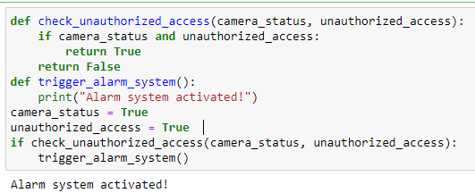

**TASK # 2:** Modus Tollens Task:

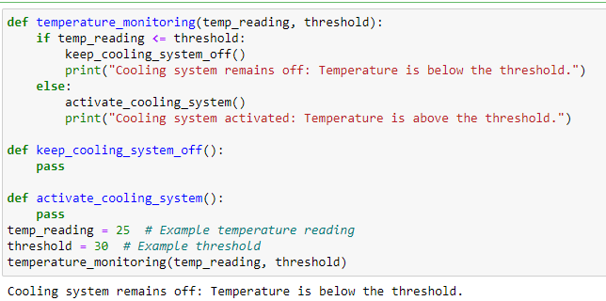

**TASK # 3:** Hypothetical Syllogism Task:

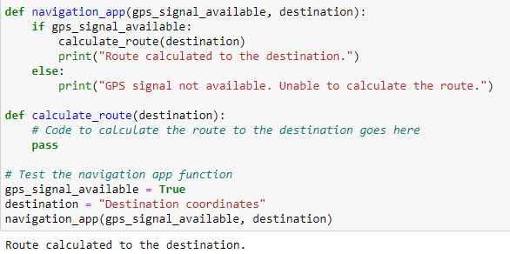

**TASK # 4:** Disjunctive Syllogism Task:

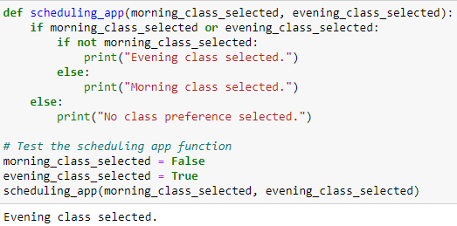

**TASK # 5:** Simplification Task:

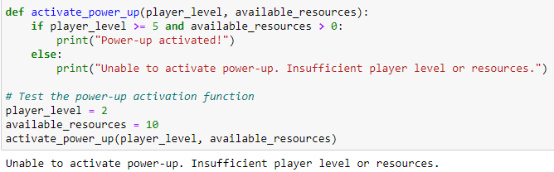

**TASK # 6:** Addition Task:

